
Technical Submittal – R 01
Feb 2020
Prepared for Endress + Hauser, Waluj Aurangabad

Dock Shelter, Dock Levellers, Scissor Lift, High Speed Door, Sectional Door, Motorized Rolling Shutter,

Contactor Name:
Shubhshree Engineering and Constructions Pvt Ltd
401-404, Sai Business centre, Osmanpura
Aurangabad-431005, MH, India.

Supplied Name: NIHVA Technologies Pvt Ltd

Prepared by,
Ms. Varsha
8551091333
NIHVA Technologies Pvt Ltd

Table of Contents

- Introduction
- Product Sample Photo
- Scope of Supply
- BOQ & Compliance
- GA Drawing
- Technical submittals
- Factory sample test reports
- Optional Items & Deviation List

- Introduction

NIHVA Technologies Pvt Ltd, Pune

NIHVA’s Head Office & manufacturing facility is located in Pune in Maharashtra (India) & sales office at various metro cities.
NIHVA is young and growing company, having experience of 7 years in industrial market. NIHVA specializes in providing integrated solutions in Door Automation & Automation Solutions.
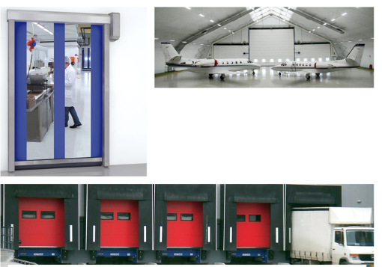

Apart from this NIHVA is also equipped in providing water management and drainage solutions (external and internal).

- Product Sample Photos

Swing Dock Levellers
Scissor Lift
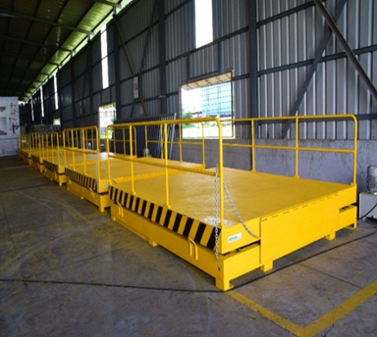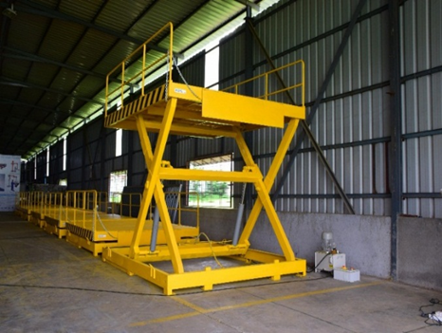
Retractable Dock Shelters
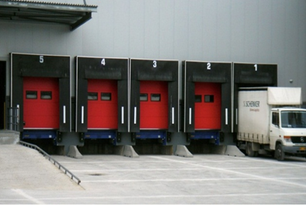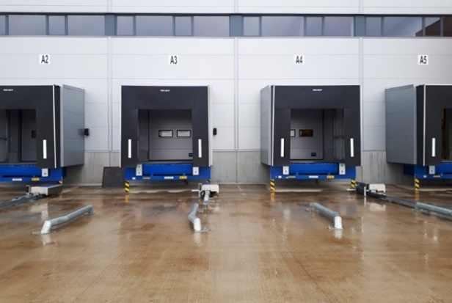

High Speed Door
Sectional Door
Single-skinned Rolling shutter make - NIHVA.

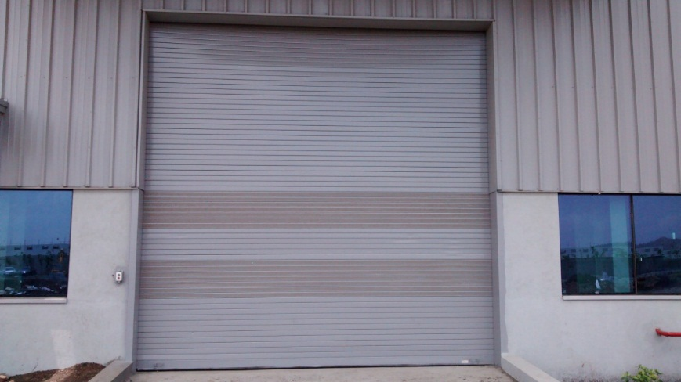

Motorised three leaf Telescopic Gate
Manual Wicket Gate
Double Sided Flap Gate:

Sliding Glass Door

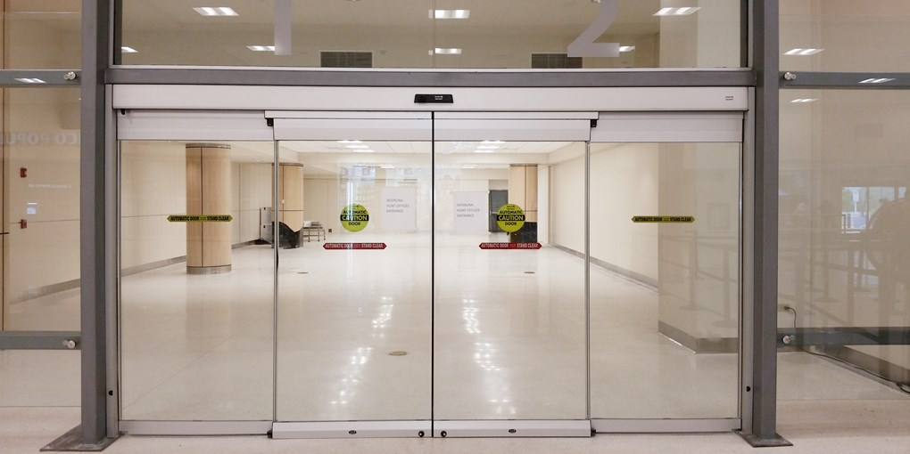

- Scope of Supply

Scope of Supply:
Sr. N | Products | Size | Qty | Remark
1 | Retractable Dock Leveler | (W) 2000 mm X (H) 2500 mm | 4 | Size As per BOQ
1 | Retractable Dock Leveler | (W) 2000 mm X (H) 3000 mm | 4 | Option – II size considering Operation Space for Operation
2 | Hot Dip Galvanized Scissor Lift | (W) 2000 mm X (L) 2500 mm | 4 | Size As per BOQ
3 | Retractable Dock Shelter | (W) 3450 mm X (L) 3400 mm | 4 | Size As per BOQ
4 | High Speed Door (Rapid Roller up Door) | (W) 4000 mm X (L) 4000 mm | 7 | Size As per BOQ
5 | Sectional Door | (W) 2500 mm X (L) 4000 mm  (W) 4000 mm X (L) 4000 mm | 1  8 | Size As per BOQ  Size As per BOQ
6 | Rolling Shutter | (W) 2500 mm X (L) 4000 mm  (W) 4000 mm X (L) 4000 mm | 4  8 | Size As per BOQ  Size As per BOQ
7 | Telescopic Sliding Gate | (W) 6000 mm X (L) 1800 mm | 1 | Size of gate to be conform
8 | Wicket Gate | (W) 1200 mm X (L) 1800 mm | 1 | Size of gate to be conform
9 | Double leaf SS Flap Barrier Gate | 1400 x 280 x 980 mm | 1 | Size of gate to be conform
10 | Sliding Glass Door | 2000 mm X 2200 mm | 2

- BOQ & Compliance

- GA Drawing

Actual GA Drawing shall be provide after confirmation of PO

- Technical submittals

Dock Levellers:
Sr. No | Description | Specification
1 | Size | (W) 2000 mm x (H) 2500 mm  (W) 2000 mm x (H) 3000 mm
2 | Quantity | 4 Nos
3 | Capacity | 15 T
4 | Control Unit Protection Class | IP54
5 | European Standards | EN 1398
6 | Coating | RAL 5010, Hot dip galvanized
7 | Control unit | Supervision 105, 105A, i105, i305 Service & fault Indicator
8 | Vertical working range  Rise above dock  Fall below dock | 250 - 620 mm  270 - 350 mm
9 | Platform tear-plate thickness with platform reinforcements according to the load capacity | 6/8, 8/10 mm
10 | Lip material & length | Steel, 400 / 500 mm
11 | Nominal voltage | 400V 3-phase

ASSA ABLOY DL6010S Swing dock
Product description:
Stationary dock leveller with swing lip with:
• Integrated frame with wall anchors (T-frames)
• Electro-hydraulic operation with two lifting cylinders
• Hydraulic cylinder swinging out of swing lip in highest platform position
• Automatic, free floating position
• One-button control unit with mains switch, including interlocking of leveler/door
• Hold-to-run button to position lip on the truck bed and to put the leveler back in parking position
• Hydraulic emergency stop in any operating position
• Automatic mechanical locking in neutral position
• Lateral torsion flexibility
• Side plates (toe guards) with warning signs both above and below dock level
• Internal wiring, plug connection
• Power supply by others
• Control Unit Protection Class IP 54
• The dock leveler meets standard demands of most loading operations and fully complies with rules and regulations of the European Standard EN 1398

Nominal width (NW) 1750, 2000, 2200.
Load bearing capacity: 60 KN

Surface:
• Surface painted in standard color RAL 5010 / RAL 9005, thickness 80 μm
Lip bearing:
• Reinforced steel tear plate swing lip
• 400 mm swing lip with 5° bend
• 40 mm bevelled lip
Hydraulics:
• Standard oil for temperature range -20° to +60° Celsius
Control unit:
• Voltage 400V, cable harness length 7m
• Display of error messages
• Service interval display
• Readout function / Memory function
Options:
Frame
□ T-200 Frame (standard frame with a height of 200mm)
□ W-Frame (welded to pre-cast frame)
□ F-Frame (flat bar frame welded to existing frame or for replacement)
□ B-Frame (box frame, for positioning dock leveler and subsequent setting in concrete)
□ P-Frame (pit frame with support from under (made by others), up to NL=3000mm)
Surface
□ Surface painted in RAL 6005 / RAL 3002, thickness 80μm
□ Surface painted with coat thickness 160μm
□ Surface hot-dipped galvanized
Hydraulics
□ Low temperature oil for temperature range -30° to +60° Celsius
□ Bio-oil (environmental protection)
Lip bearing
□ Swing lip 500mm (only for LH700 and larger)
□ Bevelled lip 100 mm
□ Straight swing lip
□ Tapered swing lip
Energy & Ergonomics
□ EPDM gap sealing
□ Slip protection and noise reduction coating

Multifunctional docking control for direct control of dock leveler, dock shelter and door with just one control unit
□ Operating dock leveler and door
□ Operating dock leveler dock shelter and door
□ Operating dock leveler and dock shelter
Control unit
□ Impulse auto button to put the leveler back in parking position
□ Parking position detection
□ Voltage 400V 
□ Cable harness extension
□ External EMERGENCY STOP button

Scissor Lift:

Sr. NO | Description | Specification
1 | Capacity | 6 Ton Point Load 15 T UDL
2 | Platform Size | (W) 2000 mm X (L) 2500 mm
3 | Shut Ht | 1000 mm
4 | Max Ht | 2200 mm
5 | Lift Ht | 1200 mm
6 | Safety Railing | Safety railing M.S SECTION 900 mm ht all side on platform & fixed
7 | Manual Lip | 3 Piece (240 + 1500 + 240) - 1 Side Only
8 | Maintenance Stopper | 2 NOS
9 | Push Button Pendent | Flexible pendent with 5 mtr Cable - 1 No
10 | Control Panel | Outside pit - 1 No
11 | Safety Bellow | All side
12 | Power Pack Inside Pit with Buzzer | 15 HP, 3 Phase - Eaton make
13 | Hydraulic Cylinder | Two numbers with Bore 150 X stroke 500 mm - Eaton make
14 | Hot Dip Galvanized | IS 2629 / EN ISO 1461 / As per ASTM
15 | Hose | Parker Hoses
16 | Cable | Polycab cables
17 | Hydraulic Oil | Grade 68 - 125 Ltr
18 | Paint | Gloosy-20Ltr
19 | Fabrication | 3500KG

Dock Shelter:
SR NO | Description | Specification
1 | Size | (W) 3450 mm x (H) 3400 mm
2 | Curtain Color | Black
3 | Parking Guides | White, Yellow
4 | Wall Fixings | Concrete, Sandwich light Concrete, Load house cavity, insulated panel
5 | Top & Side Curtains | Double Layer High Quality Polyester
6 | Thickness | 3.0 mm
7 | Weight | Approx. 3400 g/m2
8 | Continuous Roof Cover | One layer high quality Polyester
9 | Thickness | 0.5 mm
10 | Front White Patch | Reflective strips

ASSA ABLOY DS6060A Curtain dock shelter aluminium
Product description:
DS6060A Curtain dock shelter aluminium
• Frame in extruded aluminium sections
• Front and rear frame spring-loaded and connected with parallel bracing arms
• Roof construction rises automatically as truck approaches
• Continuous wall and roof cover
• Easily replaceable curtains
• Curtain quality
• Top curtain /side curtains:
• Double-layered high quality polyester, coated on both sides
• Total weight approx. 3400g/m²
• Flammability (DIN 75200)
• Tensile strength: DIN 53354
Longitudinal strength: approx. 7000N/5cm transverse strength: approx. 5000N/5cm
• Tear elongation: DIN 53363
Longitudinal strength: approx. 750N transverse strength: approx. 900N
• Continuous roof cover
• One layer high quality polyester, coated on both sides
• Total weight approx. 600g/m²
• Flammability (DIN 75200)
• Tensile strength: DIN 53354
Longitudinal strength: approx. 2500N/5cm transverse strength: approx. 2600N/5cm
• Tear elongation: DIN 53363
Longitudinal strength: approx. 250N transverse strength: approx. 250N
• Top curtain with a slit in the main wear area to minimize contact pressure from the truck
• Installation height 4500 mm above outside yard level
• Standard variants
Nominal height 3200, 3400, 3600mm
Nominal width 3250, 3450mm

• Top curtain:
□ Top curtain 1000mm
□ Splitted top curtain 1000mm (4 slits in the wear area)
□ Top curtain 1200mm
□ Splitted top curtain 1200mm (4 slits in the wear area)

• Nominal depth:
□ Nominal depth 600mm
□ Nominal depth 900mm
• Side curtain:
□ Side curtain 600mm (Nominal width 3250mm)
□ Side curtain 700mm (Nominal width 3450mm)

• Color:
□ black 
□ blue (RAL 5010, side and front curtains)
• Color of parking guides
□ white
□ yellow (sim. to RAL 1023)
Wall fixings:
□ Concrete 
□ Sandwich 
□ ISO panel wall
□ Light concrete
□ Loadhouse
Dimensions:
mm | Nominal height | 3200, 3400, 3600mm
mm | Nominal width | 3250, 3450mm
Options:
□ Digit on top curtain (Height 300mm)
□ Roof part with integrated rain channel
□ Reinforced rubber flaps in the side curtain
□ Notching on both sides
□ Corner seals to prevent draft in lower area ESR, ES 600, ES 900

High Speed Door:
Sr. No | Description | Specifications
1 | Size | (W) 4000 mm X (H) 4000 mm
2 | Quantity | 7 Nos
3 | Structure | Galvanized steel
4 | Colors | 8 standard colors - white, yellow, green, orange, red, gray, black, blue
5 | Safety | - Photocells in side columns  - Flexible soft bottom edge including wireless edge activator  - Break-away and self-repair function
6 | Operation | Operator + control unit
7 | Operating speed | Opening: up to 1,2 m/s (optional 2,0 m/s) ; Closing: 0,5 m/s
8 | Wind load resistance | Class 1 (300 Pa (N/m²)) maximum wind load while closing 50 N/m²
9 | Air permeability | Class 1 (24 m³/m²/h at 50 Pa)
10 | Water penetration | Class 2 (50 Pa (N/m²))
11 | Thermal transmittance | 6,02 W/(m²K)
12 | Lifetime expectations | 1.000.000 cycles
13 | Temperature working range | 5 °C to +40 °C
14 | Vision window | Horizontal one row of height 400 mm at eye level
15 | Radar Sensor | An infrared sensor above the door detects an object (person, vehicle) within a specified distance from the door and opens the door automatically. This is an ideal solution for frequent vehicle or personal traffic.

Sr. No | Description | Specification
1 | Size | (W) 2500 mm X (H) 4000 mm (W) 4000 mm X (H) 4000 mm
2 | Quantity | 9 Nos
3 | Vision Windows | 2 Nos at central panel
4 | Opening Direction & Mounting | Standard Lift
6 | Opening/Closing Speed | CDM9 0,28 m/s
7 | Door Material | GI Steel
8 | Panel Thickness | 42 mm Square Grid, steel sheet
9 | Filling | CFC-free polyurethane
10 | Panel Colour | RAL 9002 Grey White Powder coated
11 | Door sealant | All door sealants made of EPDM rubber, temperature resistant -30/+70
12 | Panel Flame Retardant standard | Flame retardant polyurethane foam according DIN4102-class B2.
13 | Water Penetration | EN 12425 class 3
14 | Air Permeability | EN12426 class 3
15 | Wind Load | EN21424 class 3
16 | Thermal Transittance | EN 12428 1.10W /m2K
17 | Bottom sealing | Bottom of the door to be equipped with three lip sealing made of oil resistant EPDM rubber
18 | Door safety | Doors equipped with spring break device
19 | In case of Power failure | Doors to be equipped with quick release function
20 | Operator power consumption | Operator to have a maximum power consumption of 0,37kW and a standby consumption of Maximum  15W
21 | Drive Unit & Mounting Type | Single phase 230V direct drive on shaft
22 | Emergency Operation | by Disengagement rope manual
23 | Operating Switch | Up/Down Keypad + stop button
24 | Locks : Lock bolt | The Lock bolt locks the door from the inside, without the use of a key. The Lock bolt is not visible from the outside.
25 | Environmental Green Product  Declaration Certification | As per ISO 14025 and EN 15804
26 | Interlocking | Developed for climate control & safety; If door A is open, door B cannot be opened. If door B is open, door A cannot be opened.
Sectional Door:

Motorised Rolling Shutter:
SR NO | Description | Specification
1 | Size | (W) 2500 mm x (H) 4000 mm Qty: 4  (W) 4000 mm x (H) 4000 mm Qty: 8
2 | Roller shutter curtain profile type | GI Curved Profile
3 | Mounting Location area | Inside area / Outside area
4 | Mounting Surface | Side Brackets: Optional = On Concrete /Steel & Side
5 | Curtain Panel | 1 mm thick GI Single-skinned roller shutter
6 | Curtain panel size | 75 mm Height
7 | Bottom Profile | M. S. Plate 100 mm x 2.5 mm thick with angle stiffener
8 | Side Guide Profile | M.S." U" Shaped profile 65 mm -150 mm x 3 mm thick (as per the opening width dimension)
9 | Roller Shaft | M.S. Tubular Pipe with Flange & machined shaft at the ends Pipe Día -100 to 300 mm as per w x h
10 | Side Brackets | MS Plate 3 mm to 10 mm thick, as per the opening dimension
11 | Hood Cover | Made of GI Sheet Thickness 0.8 mm with 25x25x3mm angle stiffener
12 | Surface finish | 2 Coats (each coat of 35 microns DFT) of EPOXY polyamide-based enamel finish of approved color and make over a Coat (each one coat 25 microns DFT) of EPOXY polyamide based red oxide zinc phosphate primer

Sliding Gate:

Sr. No | Description | Specification
1 | Door type | Motorized Two Leaf Telescopic Sliding Gate
2 | Size considered | Clear opening - (W) 6000 mm x (H)1800 mm
3 | Opening Direction | Horizontal - from left to right or reverse
4 | Mounting Location area | Inside area
5 | Design Pattern | Standard Tubular Design Pattern
6 | Outer Frame Tube Sizes | 80 x 80 x 3.2 mm
7 | Internal Vertical Tube Sizes | 40 x 40 x 2 mm
8 | Gap Between Tubes | 100 mm C/C
9 | Bottom Rail on ground | dia 20 mm round bright bar with heavy duty support ISMB 100 X 50 Beams
10 | Bottom Rollers | Heavy Duty Bottom Wheel With both side Bearings (chrome plated)
11 | Guide Rollers supporter during Gate movement | Nylon Rollers with Bearings both side mounted on column for support smooth movement of gate
12 | Painting | 2 Coats of EPOXY polyamide based enamel finish of approved Colour
13 | El motor make | BFT – Italy (100% imported)
14 | Operating Switch | Push Button from inside
15 | Operation | By Telescopic Mechanism
16 | Safety | Photocells, Flashing Light

Wicket Gate:

Sr. No | Description | Specification
1 | Door type | Manual Single Leaf Wicket Gate
2 | Size considered | Clear opening - (W)1200 mm x (H)1800 mm
3 | Mounting Location area | Inside area
4 | Design Pattern | Standard Tubular Design Pattern
5 | Outer Frame Tube Sizes | 80 x 80 x 3.2 mm
6 | Internal Vertical Tube Sizes | 40 x 40 x 2 mm
7 | Gap Between Tubes | 100 mm C/C
8 | Painting | 2 Coats of EPOXY polyamide based enamel finish of approved Colour
9 | Operation | Manually Opening

Double Leaf SS Flap Barrier Gate:

Sr. No | Description
1 | It has zero position of self -checking, easy for users to maintain and use.
2 | There is alarm notice function when illegal access.
3 | Avoid bump function: When the turnstile does not receive the open signals, the baffle will lock automatically.
4 | IR/mechanical dual anti-lined function: When the baffle has problem in reseeding, it will stop working automatically in certain time, and the potency is small, will make an alarm sound at the same time.
5 | Resent automatically: the passenger read effectively, the system will cancel this access authority if they will not access in certain time.
6 | Standard wiring connection: can connect with many kinds of card readers, and can remote control through the computer.
7 | High throughput, Bi-directional control, Open / Close light indication
8 | Optical beams for safety movements, Ensures rapid, efficient & safe access control
9 | Easily integrated into access control system, Automatic reset of barrier flap after each valid entry, mechanical release key for emergency cases, fire trigger input facility. In the event of power failure panels can be specified to remain closed
10 | The whole system works steadily, and the noise is very low. Size: 1400 x 280 x 980mm; Unlock time: 0.2s Pass rate: 35 person/min; Pass Width: ≤550mm; Input:  100V~240V; Driving Voltage: 24v; Environment: -25~70°c; Power Consumption: 35w; Input: 12v dry contact.

Sliding Glass Door:

Sr. No | Description | Specification
1 | Door type | Bipart Sliding Glass Door
2 | Size considered | (W)2000 mm x (H)2200 mm
3 | Main power supply | 1 ph, 230 V
4 | Operator type | Bi part operator
5 | Operation mode | Partial Opening/Auto/one way/closed/Open
6 | Battery | Battery 12 V power fail open
7 | Activation | By Radar Sensors from both sides
8 | Glass | 10mm thick toughened glass (Saint Gobain)
9 | Safety | 01 safety sensor from inside

- Factory Sample Test Report

Shall be provided along with Product

- Optional Items & Deviation List

S. N | Description | Remarks
1 | NIHVA ASSA ABLOY Dock Leveler  (W) 2000 mm X (H) 2500 mm | Complied With BOQ
2 | NIHVA Hot Dip Galvanized Scissor Lift  (W) 2000 mm X (L) 2500 mm | Complied With BOQ
3 | NIHVA ASSA ABLOY Retractable Dock Shelter  Articulated Galvanized steel zinced retractable structure  BOQ: (W) 3450 mm X (L) 3600 mm  front opening width : 2140mm + 630 side flaps on both sides | Aluminium Structure  NIHVA (W) 3450 mm X (L) 3400 mm  front opening width: 2050mm + 700 side flaps on both sides
4 | Any civil / masonry/structural work required | Not in Scope
5 | All structure support | Shall be provided with additional cost.
6 | In Case of any changes in the layout as per site requirements after the shipment of material, the additional quantities and the wastage. | Not in Scope
7 | Conduits, Cables required | Not in Scope
8 | Safety Railings in Scissor Lift | Along Length sides only
9 | Auto Lip in Dock Leveller and Scissor | Shall be provided with additional cost.

SR NO | Product | Remarks
10 | Flap Barrier | Required in SS material
10 | Flap Barrier | Double leaf Type
10 | Flap Barrier | Need to be integrated with clients RFID card
10 | Flap Barrier | Client will provide RFID tag with receiver
10 | Flap Barrier | Detail Technical specs to be provided by client (BOQ)
11 | Sliding Gate | Client has considered rectrable sliding gate but after detailed technical discussion NIHVA has proposed Telescopic Sliding Gate
11 | Sliding Gate | Sliding gate needs to Hot dip galvanized
11 | Sliding Gate | Client will provide detail dimension along with single leaf or double leaft type & required accessories
11 | Sliding Gate | Make: NIHVA
12 | Rolling Shutter | Electric Motor need to be consider Direct Drive
12 | Rolling Shutter | Curtain Profile need to be considered curved type & perforated type
12 | Rolling Shutter | Rolling shutter need to be powder coated (RAL 9006)
13 | Sectional Door | Size same as per BOQ
13 | Sectional Door | Mounting Type: STd Lift which will be confirmed on final drawing approval by client
13 | Sectional Door | Sectional door ned to be interlock with DL & scissor lift
13 | Sectional Door | Make ASSA ABLOY
14 | High Speed Door | Size same as per BOQ
14 | High Speed Door | Horizontal single vision ROW
14 | High Speed Door | Anticrash mechanism + soft safety edge & other safety parameters need to be considered
14 | High Speed Door | Make: ASSA ABLOY
15 | Dock leveler | Dock leveler need to quote in two options for different size
15 | Dock leveler | B W 2000 mm x L 3000 mm
15 | Dock leveler | Dock Leveler need to be Hot Dip Galvanized
15 | Dock leveler | Make: ASSA ABLOY
16 | Dock Shelter | The front white patch on the dock shelter need to be reflective strip
16 | Dock Shelter | Retractable Dock Shelter
16 | Dock Shelter | Make: ASSA ABLOY
17 | Scissor Lift | Hot Dip Galvanized
17 | Scissor Lift | All platform four edges should have safety edge
17 | Scissor Lift | Safety Below need to be consider
17 | Scissor Lift | Interlock with Dock Leveler & Sectional Door
17 | Scissor Lift | Make : NIHVA
18 Scope revised with additional requirement with specification as per MOM
 | Product | Make as per BOQ | Revised make
18.1 | Dock Leveler | NIHVA make | Make : ASSA ABLOY (Crawford)
18.2 | Scissor Lift | Not specified | Additional: Safety Edge & bellows added
18.3 | Retractable Dock Shelter | NIHVA make | Make : ASSA ABLOY (Crawford)  Additional : front patch should be reflective white strips
18.4 | Overhead Sectional Door | NIHVA make  Lift : Vertical Lift | Make : ASSA ABLOY (Crawford)  Lift : Standard Lift
18.5 | High Speed Door | NIHVA make  Model : RR300S | Make : ASSA ABLOY (ALBANY)  Model : HS9020G (with Anti crash Mechanism, Radar Sensor)
18.6 | Motorised Rolling Shutter | Make: NIHVA  Single skinned GI Rolling Shutter  Profile - Curved | Make : NIHVA  Single skinned Galvalume Rolling Shutter  Direct Drive Motor : Nice Italian make  Profile: Curved

